INSTRUCTION MANUAL FOR HANDLING GAS CYLINDER

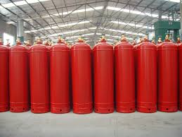
Name
Institution
Date

INTRODUCTION
The manual contains the instructions to be followed to ensure safety use of a XGK gas cylinder. The instructions should be followed to avoid any potential hazards such as fire due to an explosion. The manual will include graphics which will help the reader in understand the safety tips and also show the level of risks attached to the usage of the gas cylinder. Our organization is always prepared to offer assistance to all customers whenever need arise. All gas cylinders ought to be handled by people with the relevant expert to avoid any mistake that would cause accidents.

WARNING
A gas cylinder has a flammable gas which should be handled well to prevent any leakage. In the event of a leakage it is important to ask help from an expert to avoid any damage.
SAFE OPERATING PROCEDURE: XGK Gas Cylinders
Safety tips
- Do not store the gas cylinder together with corrosive liquids
- Do not allow any kind of leakage on the gas
- Store the gas cylinder in the appropriate temperature to avoid any form of explosion or damages to the cylinder.
- Always protect the gas nob to prevent any leakage 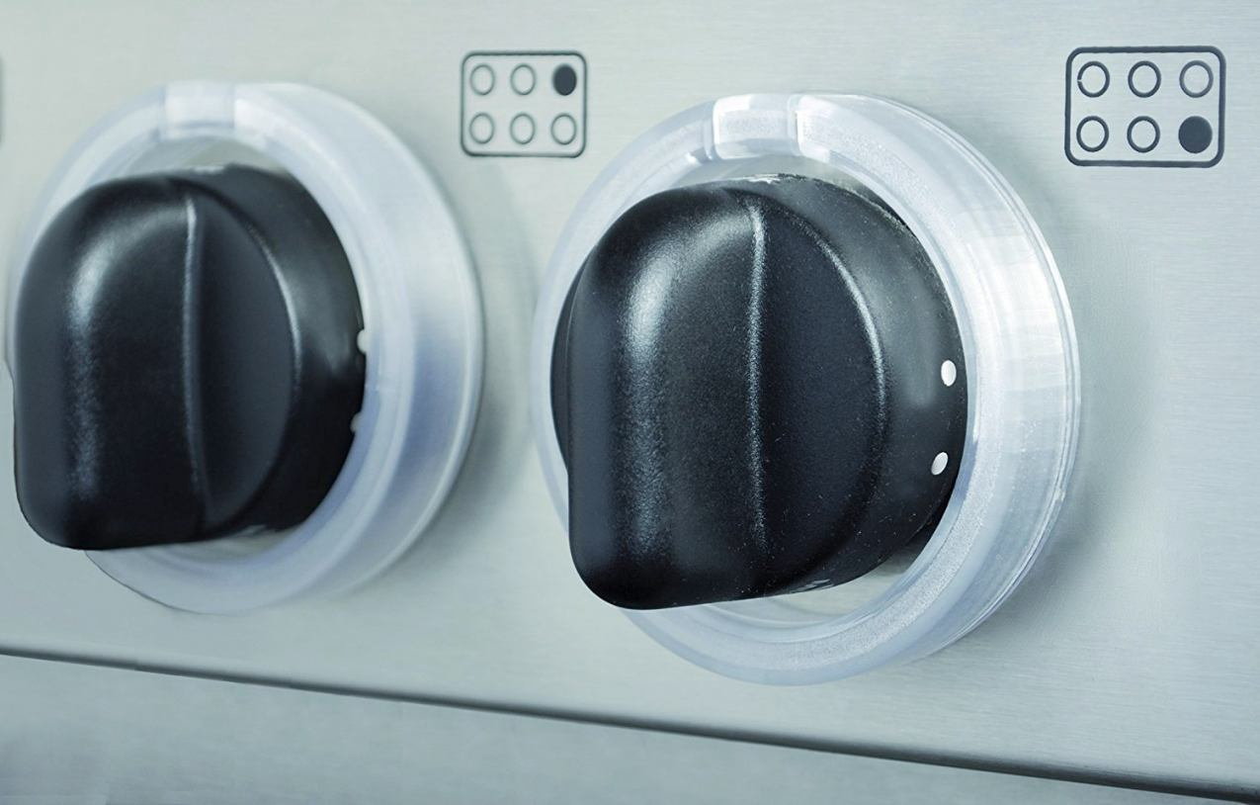
N/B: If you do not have adequate knowledge about the hazards and the risks associated with the gas cylinder always ask help from the supplier or any other expert in the field.
INDOOR HANDLING THE GAS
All the activities involved in the gas handling should be done by a person with the knowledge and understanding of the hazards involved. The person thereby must be familiar with the proper handling techniques. The cylinder is usually heavy and may cause explosions, accidents or even broke bones if not handled right. Some of safety and general precautions when using a gas cylinder include:
- Every person working with the cylinder should be properly trained
- All gas cylinders should only be used for the right purposes
- Ensure that all the parts are compatible with the cylinder pressure
- Remove any dirt on the valve and fixtures to avoid any form of leakage
- Never drag the cylinder on the floor while moving it
- If the cap it attached to the cylinder, do not move it
- Each time the valve is installed, all the parts should be inspected
- Use flashback arrestors in the event of flammable gases
- All gas cylinders should never be part of an electric circuit

Figure 1: Recommendation of how to handle your gas
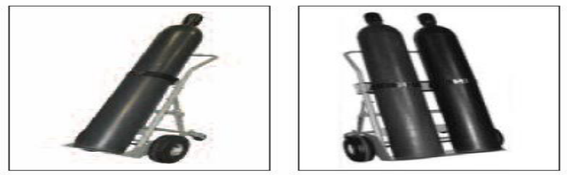
(Reference: Matheson - Safe Handling of Compressed Gases in the Laboratory and Plant 2011)
Figure 2: Example of poor storage of the gas with an arc of corrosion
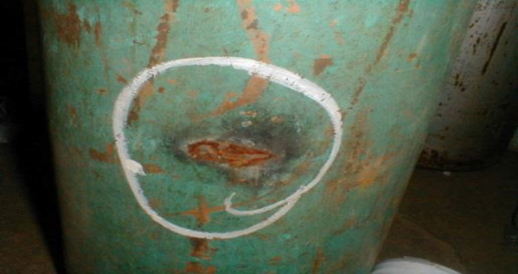
(Reference: www.engineeredinspection.com;www.nautinst.org)

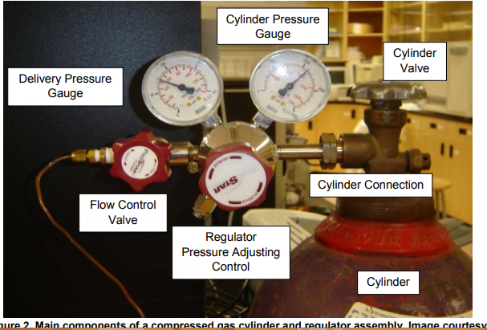
PROPER CYLINDER STORAGE
Once the gas cylinder has been received the following steps should be followed:-
- Read the label on the gas cylinder to ensure that one has received the cylinder purchased
- Inspect the gas cylinder thoroughly for any identifiable damages such as cuts or dents
- All cylinders should have a cap at the neck. Remove the cap by hand and not crowbar or screw driver.
- Inspect the value to ensure that it is not bent, damaged or faulty. A damaged value may cause gas leakage
- All cylinder values should be free from oil or dirt.
- Inspect for all the SDC components of each cylinder
- If any of the gas cylinder do not have any component do not use it. Contact the supplier for appropriate action.
- Once all the aspects have been inspected and confirmed store the cylinder in a designated area.
The room ought to be well ventilated and away from ignition, heat and from the children reach. Areas near boilers, steam and any source of heat must be avoided. Only authorized people should have access to the gas cylinder.
THE CYLINDER USE
All home gas cylinder should be connected by a qualified person. This ensures that all risks and hazards from explosion have been minimized. The following steps are followed when connecting a gas cylinder to the cooking cooker:-
- Connect the valve through the valve or regulator to deliver the gas to the gas cooker
- Tighten it well to avoid any gas leakage in the process of cooking gas
- Turn on the valve slowly to allow the gas flow through the horse pipe connected

Steps to connect your gas
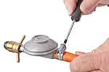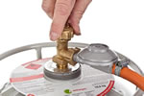
Fig 3. Smart gas cylinder using embedded system (Priya, Surekha, Preethi, Devika, and Dhivya, 2014)
MAINTENANCE OF THE CYLINDER
Always keep the cylinder clean and avoid any possible contamination or moisture exposure on the gas. This will ensure that the gas is not exposed to more risks. For example, the cylinder should not be exposed to temperatures that are above (52°C). Therefore, there is need to ensure that the gas is stored in the right space and approach.

References
Paliwal, G., Agrawal, K., Srivastava, R. K., & Sharma, S. (2014). Domestic liquefied petroleum gas: Are we using a kitchen bomb?. Burns, 40(6), 1219-1224.
Priya, K. P., Surekha, M., Preethi, R., Devika, T., & Dhivya, N. (2014). Smart gas cylinder using embedded system. International Journal of Innovative Research in Electrical, Electronics, Instrumentation and Control Engineering (IJIREEICE) Vol, 2, 958-962..

